PIZZA SALES SQL QUERIES

A.KPI’s

1. Total Revenue:

select sum(total_price)as total_revenue from pizza_sales ;

2. Average Order Value

select sum(total_price)/count(distinct order_id)as avg_order_value from pizza_sales ;



3.Total Pizza’s Sold:

select sum(quantity)as total_pizza_sold from pizza_sales ;



4.Total Order’s Placed

select count(distinct order_id)as total_orders_placed from pizza_sales ;



5.Average Pizza’s Per Order:

select sum(quantity)*1.0/count(distinct order_id)as avg_pizza_sold from pizza_sales ;



B. Daily Trend For Total Orders

select datename(dw,order_date)as order_day, count(distinct order_id)as total_no from pizza_sales

group by datename(dw,order_date);

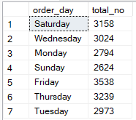

C. Monthly Trend For Total Orders

select datename(mm,order_date)as order_month, count(distinct order_id)as total_no from pizza_sales

group by datename(mm,order_date);

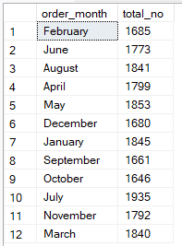

D. Hourly Trend For Total Orders

select datename(hh,order_time)as order_hour, count(distinct order_id)as total_no from pizza_sales

group by datename(hh,order_time);

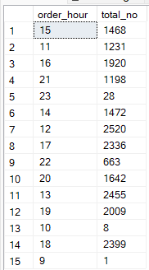

E. Percentage of Sales By Pizza Category

select pizza_category,sum(total_price)*100/(select sum(total_price) from pizza_sales) as pct_of_total_revenue from pizza_sales

group by pizza_category;

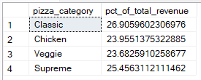

F. Percentage of Sales By Pizza Size

select pizza_size,sum(total_price)*100/(select sum(total_price) from pizza_sales) as pct_of_total_revenue from pizza_sales

group by pizza_size;

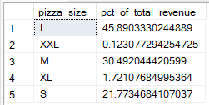

G. Total Pizza Sold By Pizza Category

select pizza_category,sum(quantity)as pizza_sold from pizza_sales

group by pizza_category

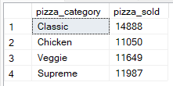

H.Top 5 Best Sellers by Revenue,Total Quantity,Total Orders

1.Revenue

select top 5 pizza_name,sum(total_price) as total_revenue from pizza_sales group by pizza_name

order by total_revenue desc

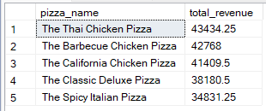

2.Quantity

select top 5 pizza_name,sum(quantity) as total_quantity from pizza_sales group by pizza_name

order by total_quantity desc

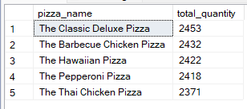

3.Orders

select top 5 pizza_name,count(distinct order_id) as total_quantity from pizza_sales group by pizza_name

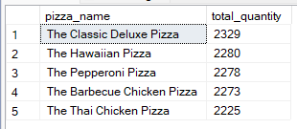order by total_quantity desc

H. Bottom 5 Worst Seller by Revenue,Total Quantity,Total Orders

1.Revenue

select top 5 pizza_name,sum(total_price) as total_revenue from pizza_sales group by pizza_name

order by total_revenue asc

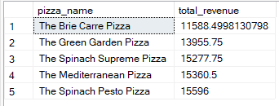

2.Quantity

select top 5 pizza_name,sum(quantity) as total_quantity from pizza_sales group by pizza_name

order by total_quantity asc

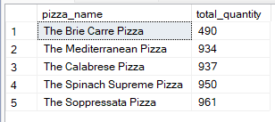

3.Orders

select top 5 pizza_name,count(distinct order_id) as total_quantity from pizza_sales group by pizza_name

order by total_quantity asc

